**ASSIGNMENT 3**

1.Create a Bucket in IBM object storage.

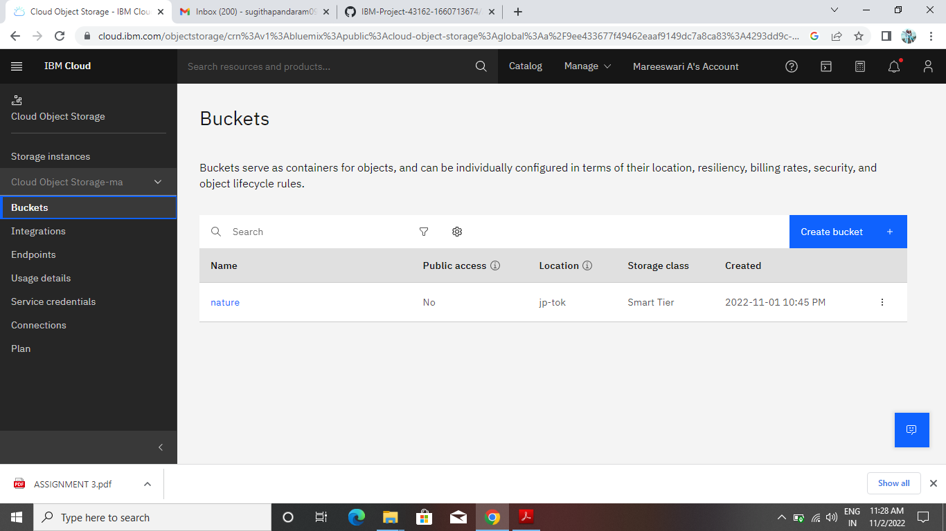

2.Upload an 5 images to ibm object storage and make it public. write html code to displaying all the 5 images.

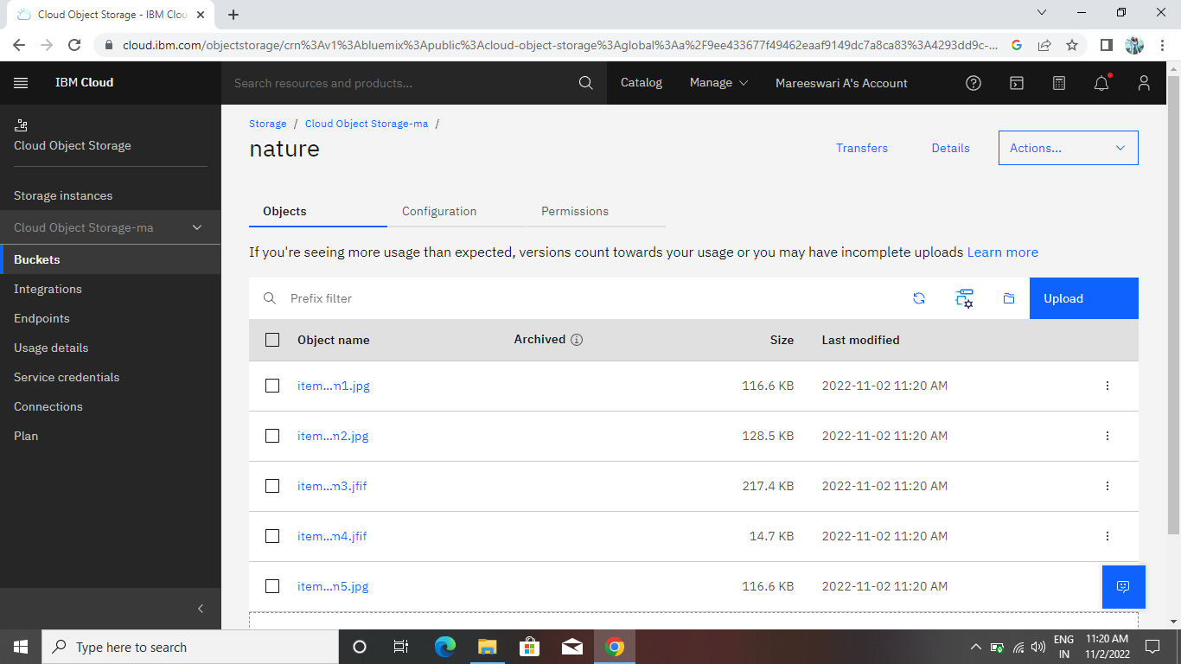

HTML Code to display the images in IBM Object Storage.

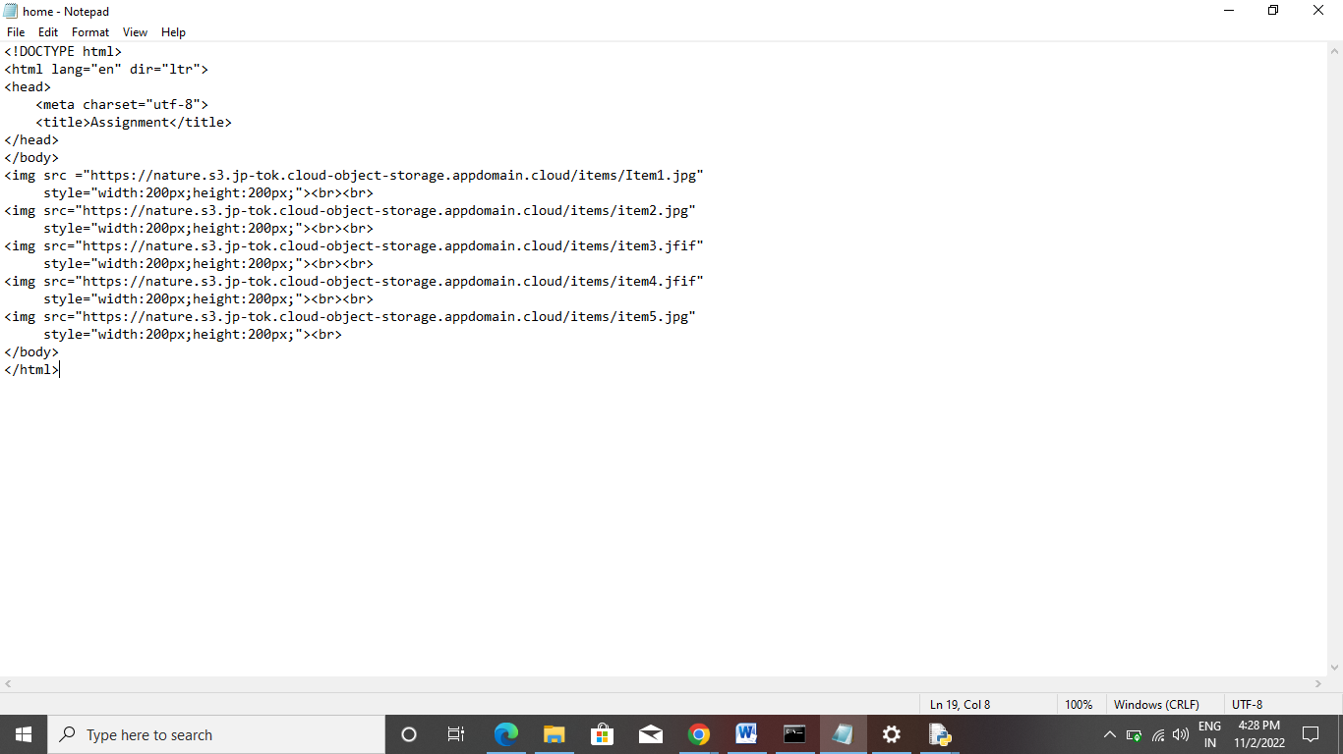

Output:

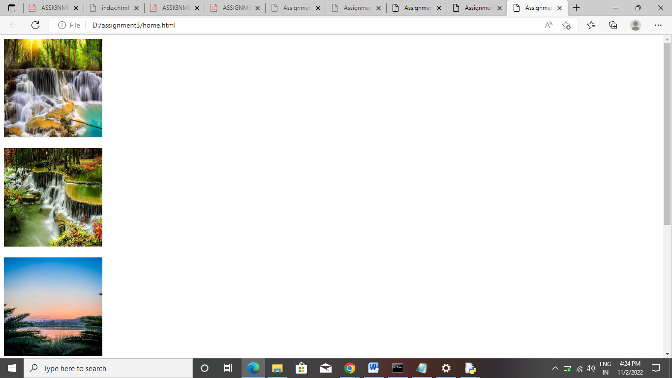

3.Upload a css page to the object storage and use the same page in your HTML code.

H1{

Color : green;

}

H1{

Color : red;

}

Body{

Back-ground color : white;

}

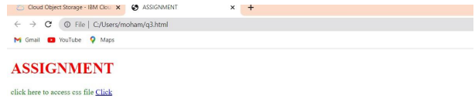

*4.Design a chatbot using IBM Watson assistant for hospital. Ex: User comes with query to know the branches for that hospital in your city. Submit the web URL of that chat bot as a assignment.*

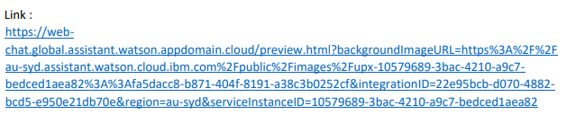

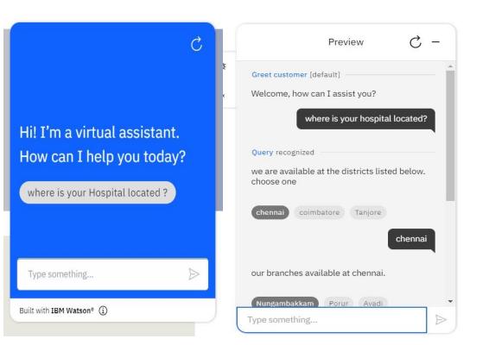

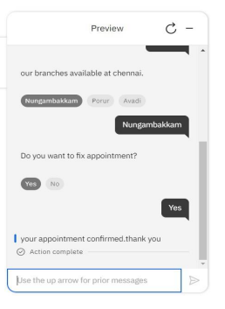

5.Create Watson assistant service with 10 steps and use 3 conditions in it. Load that script in HTML page.

